8th ANNUAL MEB DEB
GOLF OUTING
TO SUPPORT Deb’s dogs


July 18th 9 AM SHOTGUN SPRINGBROOK GOLF CLUB $280 per team
includes golf and meal Optional $20 skins game 1st and 2nd place prizes.
Registration due by July 16^{th CALL} 567.825.2219 or
Drop off or mail to: Springbrook Golf Club
4200 Ottawa Rd Lima 45801 All proceeds go directly to Deb’s Dogs
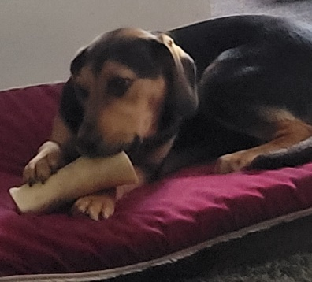
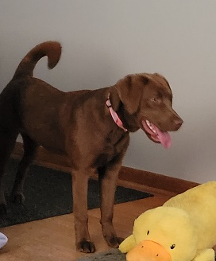
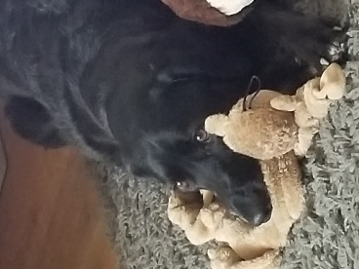

Sponsor Opportunities
$600 Corporate Sponsor includes logo on banner by clubhouse and team entry
$350 Silver Sponsor includes hole sign sponsor and team entry
$100 Bronze Sponsor includes hole sign sponsor
We also accept donations of cat and dog food, cat litter, and monetary donations

Debs dogs is a 501(c)3 nonprofit. We are an all-volunteer pet rescue and started 15 years ago. We rescue strays, dogs from the dog warden and some owner surrenders. Many of the dogs and cats we rescue are in dire need of vet care. We get a lot of calls from local law enforcement and individuals about injured animals. We always try our best to help as many pets as we can. Some of the cases we rescue are cats and dogs hit by cars, heartworm positive dogs, animals with eye injuries, dogs and cats with broken legs, dogs and cats with mange and flea infested animals. We also rescue a lot of abused pets that need love and care to be able to trust people. Every pet we rescue gets all the vet care it needs. After they are healthy enough, they are spayed/neutered and placed into a home with a loving family. Deb and all her wonderful volunteers are very dedicated and passionate about making a positive difference in the lives of the animals that need help. The majority of the pets we rescue are from Allen County.

